Clan Wallace Society 50th Anniversary Commemorative Coin Fundraiser

To mark the occasion of the 50th anniversary of the founding of the Clan Wallace Society in Salado Texas, a commemorative coin has been created. We are using the coin as a fundraiser for ongoing and future projects.
On one side of the coin is the state of Texas with a banner containing the dates 1966-2016. The background is the Wallace tartan and the Scottish Flag is near the panhandle. The outside of the coin is encircled with Celtic knots and the words Clan Wallace Society.
The other side of the coin is the Clan Wallace crest surrounded with the plant badge of Oak leafs and acorns.
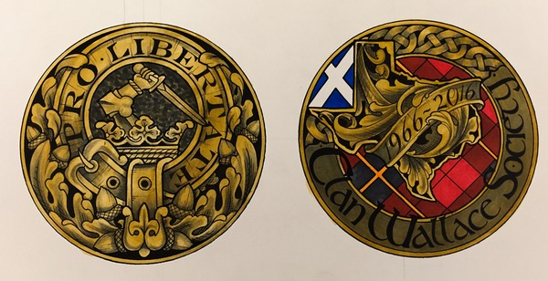
The coins are 1.75” in diameter
To obtain your commemorative coins please fill out the information below and send along with your check made out to Clan Wallace Society to: Secretary Clan Wallace Society - PO Box One - Trenton, SC 29847
Name: _____________________________________________________________________
Address: ____________________________________________________________________
City: _______________________________________________________________________
State and Zip code: ___________________________________________________________
Email Address: ______________________________________________________________
Number of Coins: ______ Amount of Donation: _____________________________________
Minimum of $10.00 donation per coin

