The Clan Wallace Society Worldwide (CWSW)
Rewards Program

Clan Wallace fulfills the principles of its Articles of Incorporation by reprinting out of date books about the history of Scotland, by collecting, restoring, and preserving places and objects of interest to the general public, especially to the Clan and Family of Wallace. An early project was the purchase of five bonze (colored) plates to complete the Wallace Monument in Elderslie, the main reason CWSW was formed in 1966. The plaques were placed in 1970.
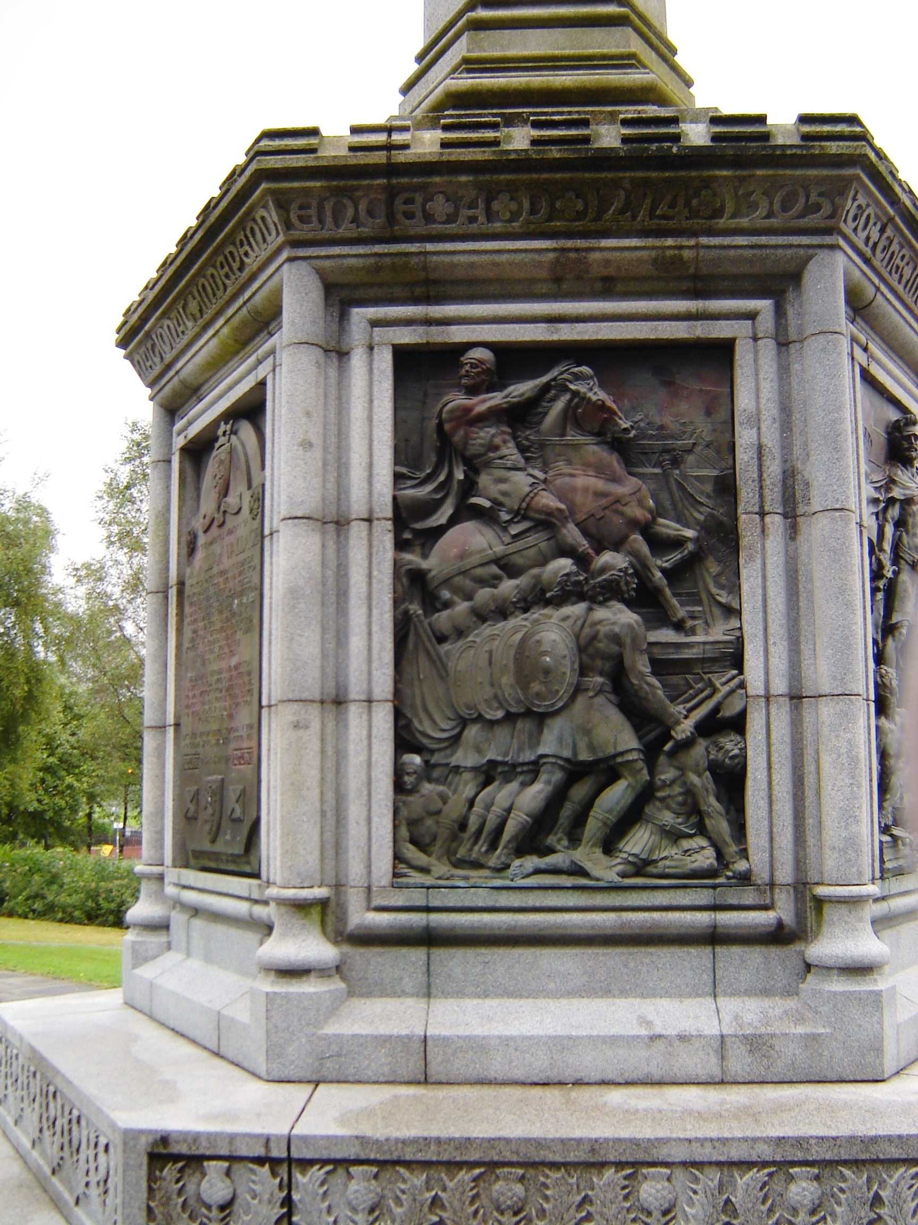

Wallace Monument in Elderslie

Clan Wallace has officially established a Rewards Program to give contributors the opportunity to assist in the implementations of its stated goals. It provides a positive method for individuals to show their support and entrepreneurial spirit, while receiving in return tangible and attractive tokens of gratitude designed specifically for our Clan Society. Donations of any size can be made, and can be tailored to an individual’s ability to give over any time period, and all contributions to the Rewards Program are
greatly appreciated. Rewards are provided to the contributor as each Reward Level is reached. Larger donations that exceed other Reward levels will result in the higher Reward and all subordinate Reward Level elements being awarded, except for the Certificates. Together, we can achieve Society goals through the Rewards Program and our tax-deductible donations. Every donation, regardless of size, helps the Society accomplish its goals. We invite everyone to participate in the Rewards Program. For more information, go to www.clanwallace.org/rewards/rewards.html.
Rewards Program Administration

All donations are recorded in personal accounts for ongoing action. All donations are welcomed and are cumulative. When a person makes further donations they are recorded in their personal account and they receive those Rewards. Contributors receive a letter from the Society Treasurer acknowledging their contribution, notice of the amount that is tax deducible, and a citation of CWSW' Tax Exempt status. Contributors will also receive a Letter from the President congratulating the donor on their Reward, a Certificate, and Newsletter publicity. This tiered level of rewards was developed to thank contributors for their generosity. The five levels of Rewards are depicted at the right.
Members, non-members, and organizations may make donations to the Rewards Program by sending name, address, phone number, and e-mail addresses along with their donation checks in the name of the Clan Wallace Society Worldwide to:
John R. Wallace, Chairman
CWSW Rewards Program
110 Azalea Drive
Walterboro, SC 29488-2605

CWSW is a Tax-Exempt 501(c)(3), non- profit organization.
Reward Level | Reward Level
Circle of the Thistle Lapel Pin  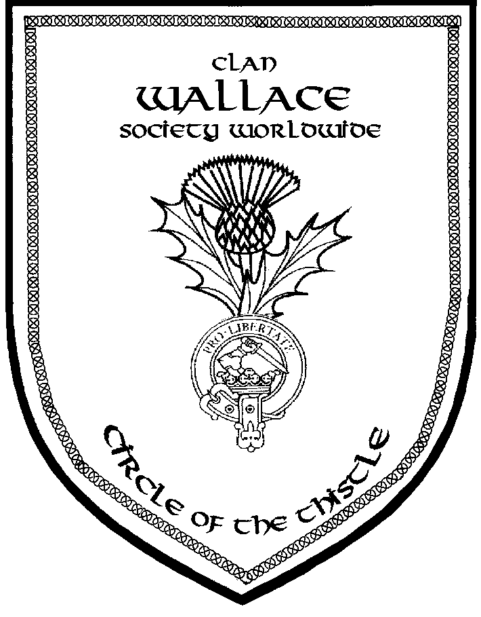  (1 1/4" tall)  $100 to $199 | Circle of the Knight Medal and Miniature Medal on Tartan Ribbon  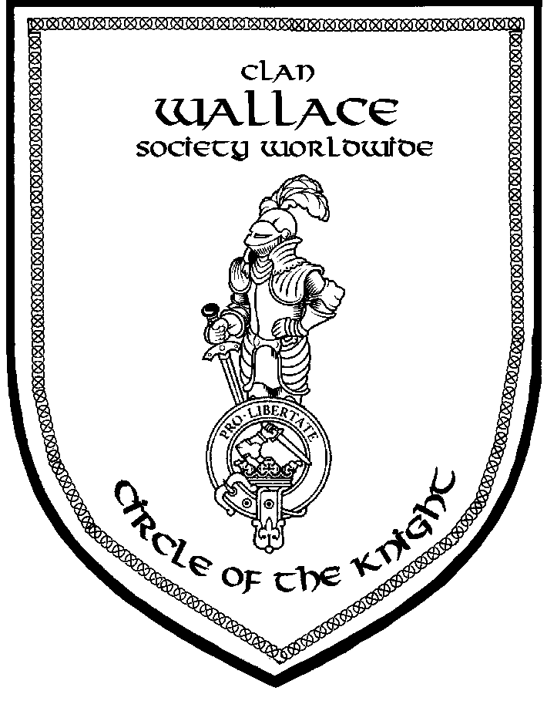  $1000 to $4999
Circle of the Cross Lapel Pin  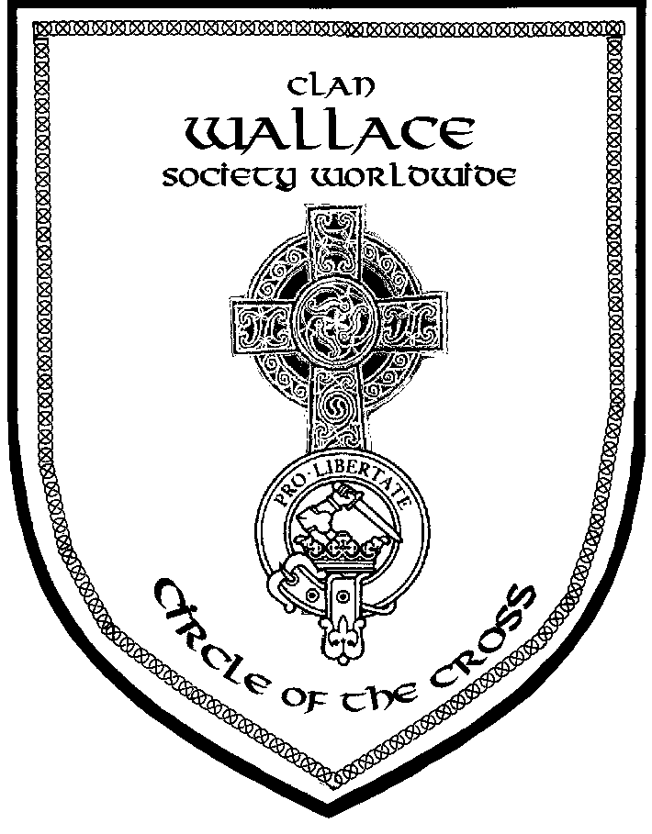  (1 1/4" tall)  $200 to $499 | Circle of Sir William Wallace Medallion on Tartan Neck Ribbon In Presentation Box  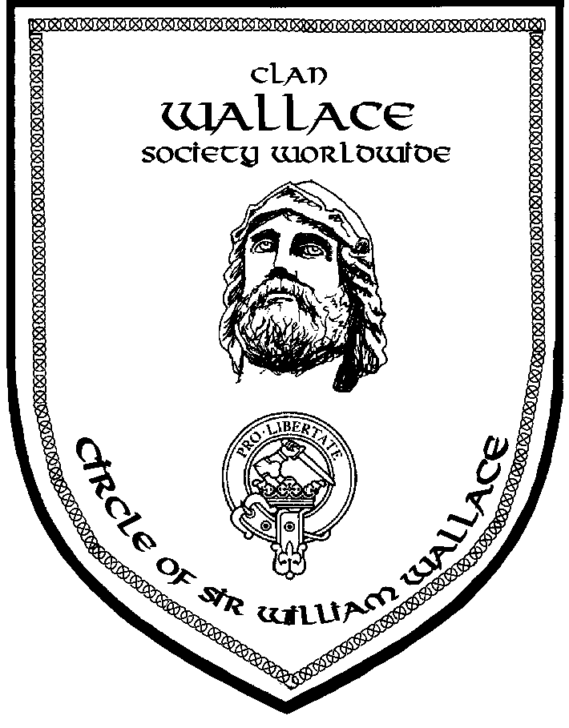  $5000 and over
Circle of the Saltire Lapel Pin
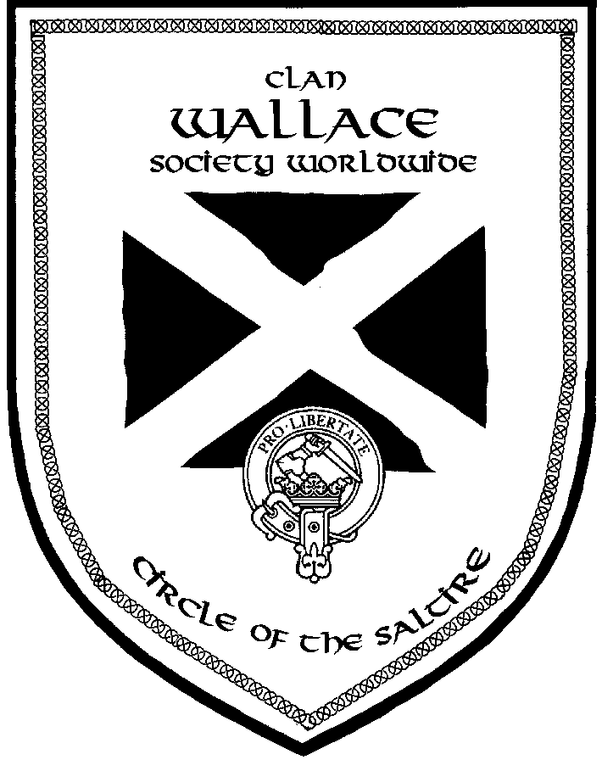
(1 1/4" tall)
$500 to $999
Recent History of Restoration and Preservation Projects
The following successes are a direct result of donations made to the Rewards Program:
- 2005: Donation to the Stirling Smith Museum and Art Gallery for Portrait
- 2005: Wallace Mural - Wallaceburg ON
- 2006: Donations to preserve the Wallace Yew Tree at Elderslie damaged by vandalism and lightning
- 2007/2008: Donations to support the Wallace700 Association in Aberdeen
- 2008: Wallace Walkway Paving Stone to help build the Culloden Battlefield Visitors Center
- 2008: Paving Brick at Robert Burns Statue in Milwaukee

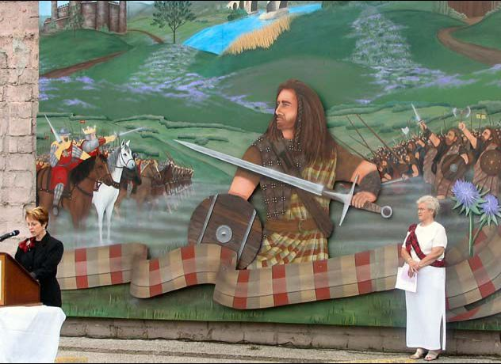

Wallace Mural at Wallaceburg ON

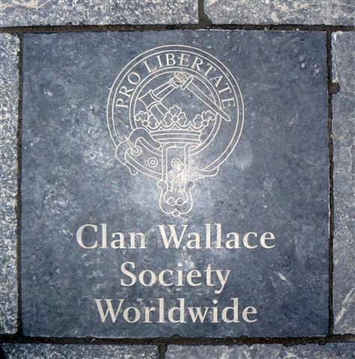

Paving Stone in the Culloden Battlefield

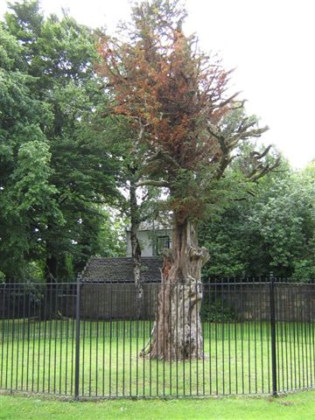

Rejuvenated Wallace Yew Tree at Elderslie

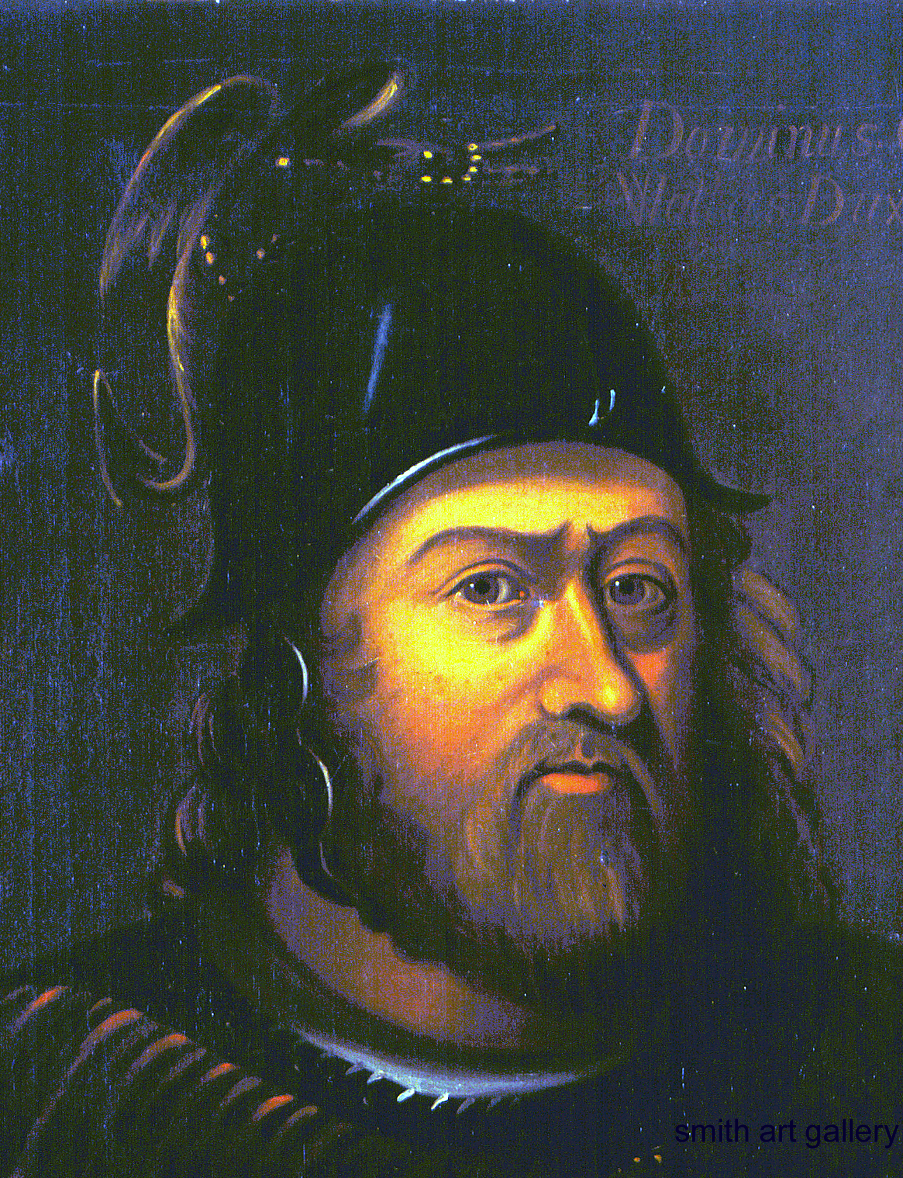

Sir William Wallace Painting at Smith Museum That CWSW Helped Purchase

Clan Wallace

Society

Worldwide

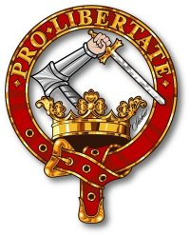

Rewards Program

